**Лабораторная работа 4.1**

**Вариант 2**

**Анищенко Арсений**

**3 курс 3 группа**

**Статическая маршрутизация**

Network 1

ip/mask 170.16.0.0/17

ip 170.16.0.0

mask 255.255.128.0

Network 2

ip/mask 170.17.0.0/17

ip 170.17.0.0

mask 255.255.128.0

Network 3

ip/mask 170.18.0.0/17

ip 170.18.0.0

mask 255.255.128.0

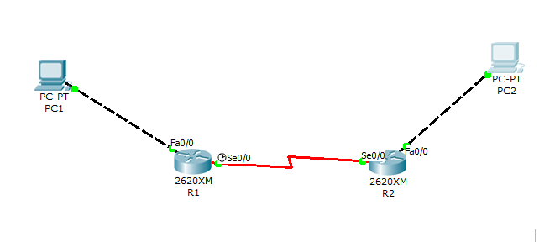

1. **Routers serial configuration**

R1 with Network 2:

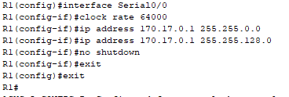

R2 with Network 2:

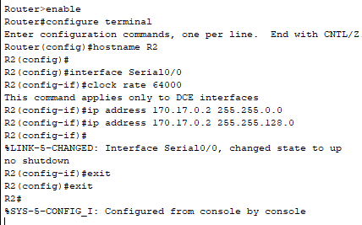

Connection :

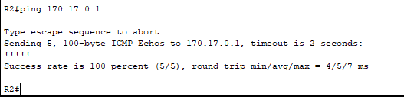

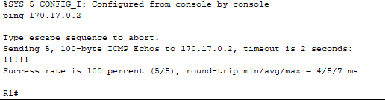

**2. Fast Ethernet configuration**

R1 with Network 1:

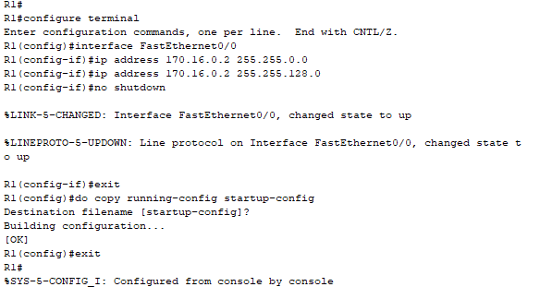

R2 with Network 3:

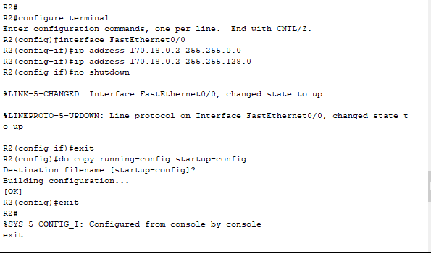

Connection PC1 to R1 and PC2 to R2:

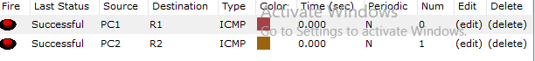

1. **Setting default gateways.**

For R1 (Networks 1 and 2)

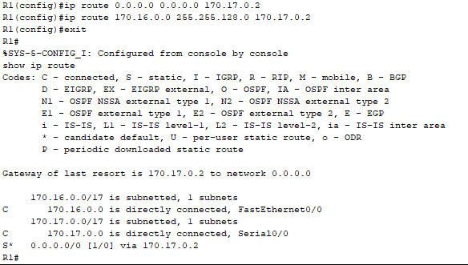

For R2 (Networks 2 and 3)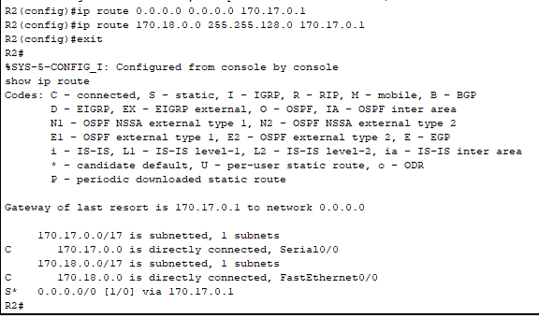

Connection between PC1 and PC2 and vice versa